16.33:
To move from constructive interference to destructive interference, the path difference must change by 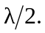If you move a distance toward speaker B, the distance to B gets shorter by and the difference to A gets longer by so the path difference changes by 2x.
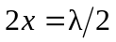and 